De tafels

Moet je een deelsom uitrekenen? Bedenk welke keersom daarbij hoort!

|  |  |  |  |  |  |  |  |  |  |  |
| --- | --- | --- | --- | --- | --- | --- | --- | --- | --- | --- |
| x | 1 | 2 | 3 | 4 | 5 | 6 | 7 | 8 | 9 | 10 |
| 1 | 1 | 2 | 3 | 4 | 5 | 6 | 7 | 8 | 9 | 10 |
| 2 | 2 | 4 | 6 | 8 | 10 | 12 | 14 | 16 | 18 | 20 |
| 3 | 3 | 6 | 9 | 12 | 15 | 18 | 21 | 24 | 27 | 30 |
| 4 | 4 | 8 | 12 | 16 | 20 | 24 | 28 | 32 | 36 | 40 |
| 5 | 5 | 10 | 15 | 20 | 25 | 30 | 35 | 40 | 45 | 50 |
| 6 | 6 | 12 | 18 | 24 | 30 | 36 | 42 | 48 | 54 | 60 |
| 7 | 7 | 14 | 21 | 28 | 35 | 42 | 49 | 56 | 63 | 70 |
| 8 | 8 | 16 | 24 | 32 | 40 | 48 | 56 | 64 | 72 | 80 |
| 9 | 9 | 18 | 27 | 36 | 45 | 54 | 63 | 72 | 81 | 90 |
| 10 | 10 | 20 | 30 | 40 | 50 | 60 | 70 | 80 | 90 | 100 |

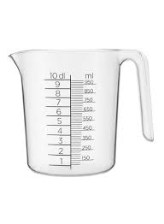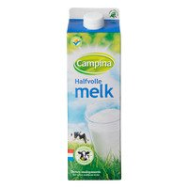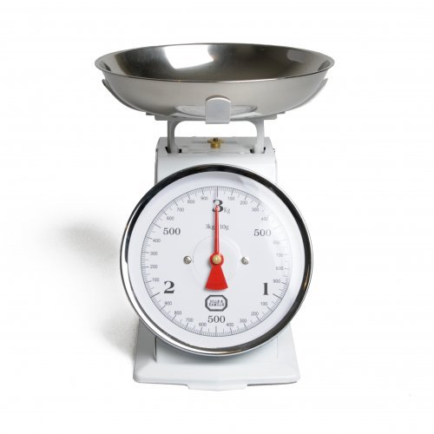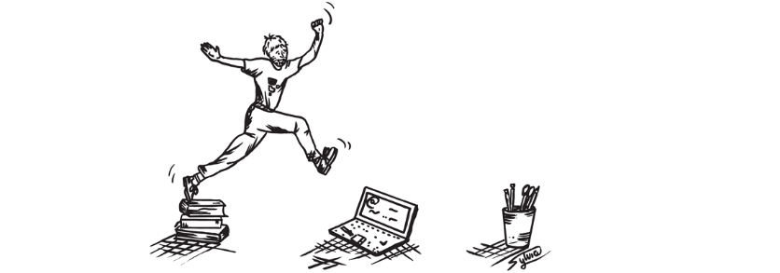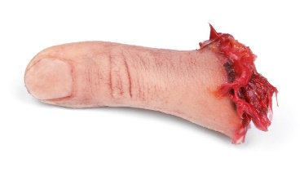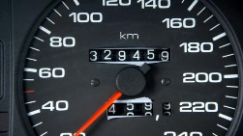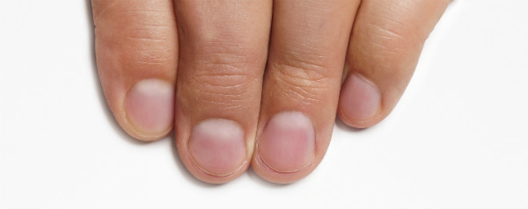

Kiloliter (kl) – Hectoliter (hl) – Decaliter (dal) – Liter (L) – Deciliter (dl) – Centiliter (cl) – Milliliter (ml)

1 L - 1000 ml

1 L - 100 cl

1 L **-** 10 dl

Kilogram (kg) – Hectogram (hm) – Decagram (dag) – Gram (g) – Decigram (dg) – Centigram (cg) – Milligram (mg)

1 kg - 1000 g

1 g - 1000 mg

4

5

Metriek stelsel

Kilometer (km) – Hectometer (hm) – Decameter (dam) – Meter (m) – Decimeter (dm) – Centimeter (cm) – Millimeter (mm)

1 cm = 10 mm

1 m = 100 cm

1 km = 1000 m

Is de deelsom 20 : 5?

Zoek in de tafel van 5 naar het antwoord 20.

5 x …. = 20

5 x **4** = 20 dus 20 : 5 = **4**!

4

5

5 x 4 = 20

4 x 5 = 20

20 : 5 = 4

20 : 4 = 5

20

**Spiekblad Rekenen**

Getallenlijn

|  |  |  |  |  |  |  |  |  |  |
| --- | --- | --- | --- | --- | --- | --- | --- | --- | --- |
|  |  |  |  |  |  |  |  |  |  |
|  |  |  |  |  |  |  |  |  |  |

0 5 10 15 20 25 30 35 40 45 50 55 60 65 70 75 80 85 90 95 100

Honderveld

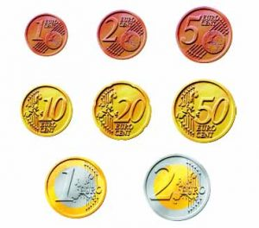

-10

-1 getal +1

+10

|  |  |  |  |  |  |  |  |  |  |
| --- | --- | --- | --- | --- | --- | --- | --- | --- | --- |
| 1 | 2 | 3 | 4 | **5** | 6 | 7 | 8 | 9 | **10** |
| 11 | 12 | 13 | 14 | **15** | 16 | 17 | 18 | 19 | **20** |
| 21 | 22 | 23 | 24 | **25** | 26 | 27 | 28 | 29 | **30** |
| 31 | 32 | 33 | 34 | **35** | 36 | 37 | 38 | 39 | **40** |
| 41 | 42 | 43 | 44 | **45** | 46 | 47 | 48 | 49 | **50** |
| 51 | 52 | 53 | 54 | **55** | 56 | 57 | 58 | 59 | **60** |
| 61 | 62 | 63 | 64 | **65** | 66 | 67 | 68 | 69 | **70** |
| 71 | 72 | 73 | 74 | **75** | 76 | 77 | 78 | 79 | **80** |
| 81 | 82 | 83 | 84 | **85** | 86 | 87 | 88 | 89 | **90** |
| 91 | 92 | 93 | 94 | **95** | 96 | 97 | 98 | 99 | **100** |

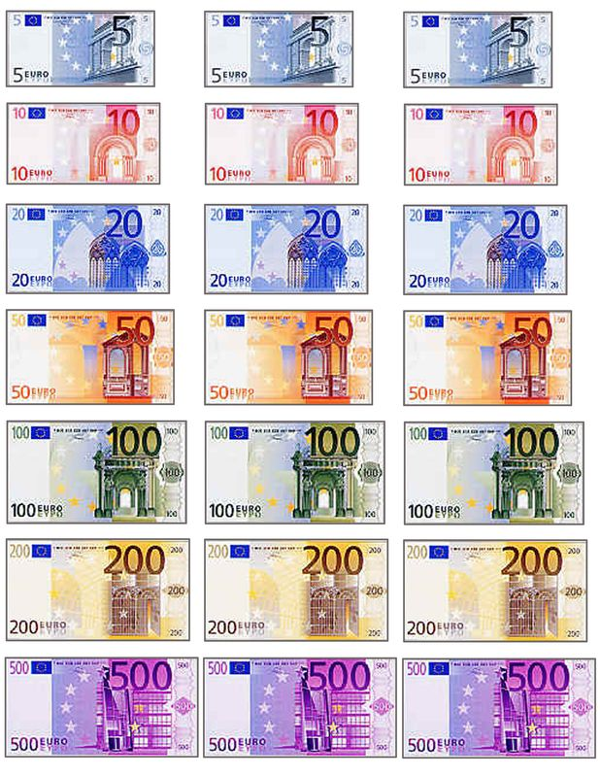

Honderd = 100

Duizend = 1000

Tienduizend = 10.000

Honderdduizend = 100.000

Miljoen = 1.000.000

Tienmiljoen = 10.000.000

Honderd miljoen = 100.000.000

Miljard = 1.000.000.000

X 10

Muntgeld

100 cent = 1 euro

Briefgeld